

Excel Assignment - 21

1. Write a VBA code to enter your name in A1 Cell using Input Box and once you enter the name display a message box that says the name has been entered.

Ans=>

Sub EnterNameAndDisplayMessage()

Dim enteredName As String

' Prompt the user to enter a name

enteredName = InputBox("Enter your name:", "Name Entry")

' Check if the user entered a name

If enteredName <> "" Then

' Enter the name in cell A1

Range("A1").Value = enteredName

' Display a message box indicating that the name has been entered

MsgBox "Name '" & enteredName & "' has been entered in cell A1.", vbInformation

Else

' Display a message if the user canceled the input

MsgBox "No name entered. Operation canceled.", vbExclamation

End If

End Sub

1. What are Userforms? Why are they used? How to fill a list box using for loop.

Ans=>

UserForm is a custom dialog box or form in excel or form in excel that you can create and design using the Visual Basic for Applications programming language. They provide a way to create interactive interfaces for users to input data, make selections, and perform various tasks within excel.

Why are UserForms used:

1. Customised Interfaces: UserForms allow you to create customized and user-friendly inerfaces tailored to specific or data entry requirements.
2. Automation: UserForms can be used to automate certain processes by guiding users through step-by-step procedures or capturing specific information.
3. Data Validation: you can use UserForms to implement data visualization, ensuring that users enter accurate and valid information.
4. What is an array? Write a VBA code to enter students and their marks from the below table.

Ans=> Array is a collection of values, variables, or objects arranged in rows and columns. Excel supports both one-dimensional arrays and two-dimensional arrays. Arrays are useful for performing operations on a set of data simultaneously.

Ans=>

|  |  |
| --- | --- |
| Name | Marks |
| John | 85 |
| Jane | 92 |
| Bob | 78 |
| Alice | 95 |
|  |  |

Sub EnterStudentsAndMarks()

Dim studentData As Variant

Dim studentCount As Integer

Dim i As Integer

' Assuming data starts from A2 and B2

studentData = Range("A2:B" & Cells(Rows.Count, 1).End(xlUp).Row).Value

studentCount = UBound(studentData, 1)

' Loop through the array and process each student

For i = 1 To studentCount

Dim studentName As String

Dim studentMarks As Integer

' Retrieve data for each student

studentName = studentData(i, 1)

studentMarks = studentData(i, 2)

' You can perform any desired operation with the student data here

' For example, enter the data into another sheet or perform calculations

' For demonstration purposes, print the student data in the Immediate Window

Debug.Print "Student Name: " & studentName & ", Marks: " & studentMarks

Next i

End Sub

1. Use the following data to create a pie chart using VBA code. Use Font

- ‘Times new Roman’, Size -14, Bold, Title - Piechart’ and you are per to use colours as per your taste.



Ans=>

Sub CreatePieChart()

Dim chartObj As ChartObject

Dim rng As Range

' Define the range that contains the data for the pie chart

Set rng = ThisWorkbook.Sheets("Sheet1").Range("C1:D187")

' Create a new chart

Set chartObj = ThisWorkbook.Sheets("Sheet1").ChartObjects.Add( _

Left:=100, Width:=375, Top:=50, Height:=225)

With chartObj.Chart

.SetSourceData Source:=rng

.ChartType = xlPie

' Format the chart title

.HasTitle = True

.ChartTitle.Text = "Piechart"

.ChartTitle.Font.Name = "Times New Roman"

.ChartTitle.Font.Size = 14

.ChartTitle.Font.Bold = True

' Customizing the pie chart colors

.SeriesCollection(1).Points(1).Format.Fill.ForeColor.RGB = RGB(255, 0, 0) ' Red

.SeriesCollection(1).Points(2).Format.Fill.ForeColor.RGB = RGB(0, 255, 0) ' Green

.SeriesCollection(1).Points(3).Format.Fill.ForeColor.RGB = RGB(0, 0, 255) ' Blue

' Add more colors as needed

End With

End Sub

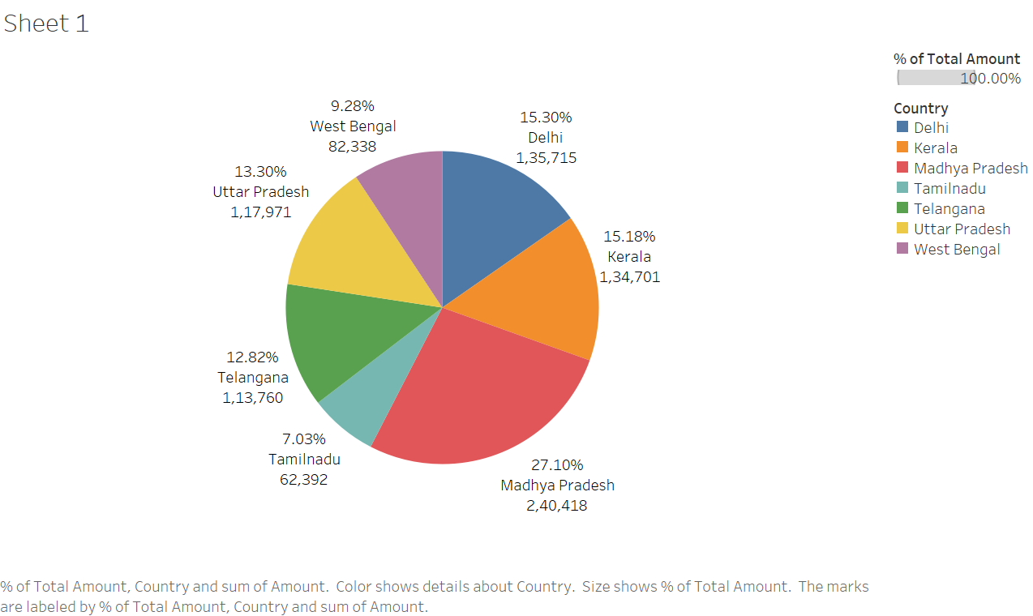

1. Check the dataset in the link given below and create a pivot table using VBA showing the sales for the year from stationary category.

https://docs.google.com/spreadsheets/d/1IRSEnmgz8Ro276- GslknRNk0zlrB5CZH1YrnT71kqFM/edit?usp=sharing

Ans=>

Sub CreatePivotTable()

Dim ws As Worksheet

Dim pt As PivotTable

Dim pf As PivotField

Dim pi As PivotItem

Dim rng As Range

' Set the worksheet

Set ws = ThisWorkbook.Sheets("Sheet6")

' Define the data range

Set rng = ws.Range("A1").CurrentRegion

' Add a new worksheet for the pivot table

Sheets.Add(After:=Sheets(Sheets.Count)).Name = "PivotTableSheet"

Set wsPivot = Sheets("PivotTableSheet")

' Create the pivot table

Set pt = wsPivot.PivotTableWizard(SourceType:=xlDatabase, SourceData:=rng, TableDestination:=wsPivot.Range("A3"), TableName:="MyPivotTable")

' Add "Category" field to Rows

Set pf = pt.PivotFields("Category")

pf.Orientation = xlRowField

pf.Position = 1

' Add "Amount" field to Values

Set pf = pt.PivotFields("Amount")

pf.Orientation = xlDataField

pf.Function = xlSum

pf.Position = 1

' Filter the pivot table to show only "Stationary" category

Set pf = pt.PivotFields("Category")

pf.PivotItems("Stationary").Visible = True

For Each pi In pf.PivotItems

If pi.Name <> "Stationary" Then

pi.Visible = False

End If

Next pi

End Sub

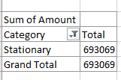

1. Write step by step procedure to protect your workbook using a password.

Ans=>

a)Open your workbook: launch Microsoft Excel and open the workbook you want to protect, save the workbook.

b)Navigate to the “File” tab: Click on the “File” tab ribbon to access the Backstage view.

c) Go to “Info”: click on the “Info” to access workbook related options.

d) select “Protected Workbook”: under “Info” section you will find the “Protect Workbook” option. Click on the dropdown arrow next to it.

e)Choose “Encrypt with password”: select “Encrypt with Password” from the dropdown menu.

f) Set a Password: a dialog box will appear prompting you to enter a password. Type the password you want to use to protect the workbook.

g)Confirm the password: After entering the password youll be asked to confirm it by typing it again in the conformation box.

h)Save the workbook: click “OK”.